Cursor positions:
- 0 s
- 0.2 s
- 0.29695 s
- 0.29885 s
Generally, Single AP Fine (the file you will be analyzing) is the sixth abf file in a sample set (sixth protocol ran when patching)
(approximately) What you should see when you first open the abf file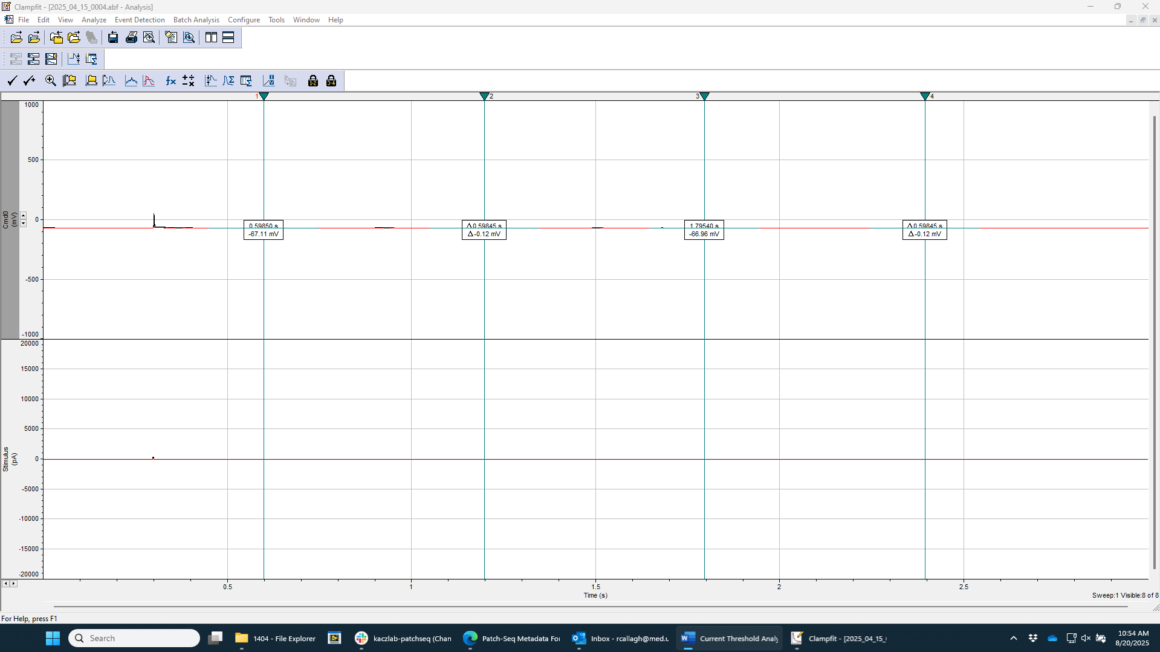
Cursor Positions:
- Double click on any of the cursors to begin changing their positions
- From cursor 1 through 4, enter the following values to move the cursors to the proper positions
  - 0 s
  - 0.2 s
  - 0.29695 s
  - 0.29885 s

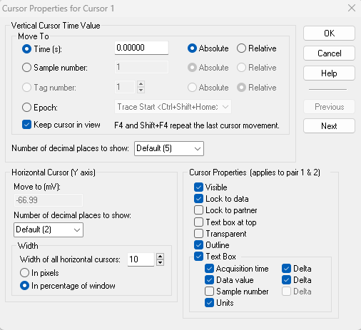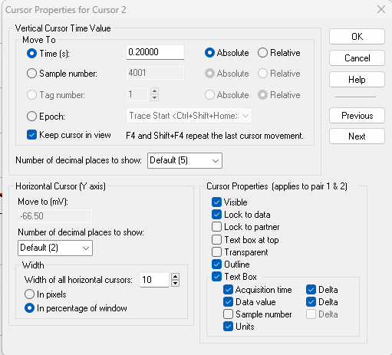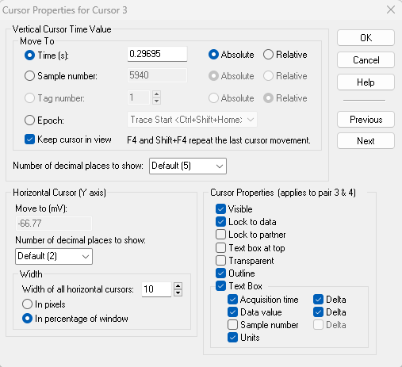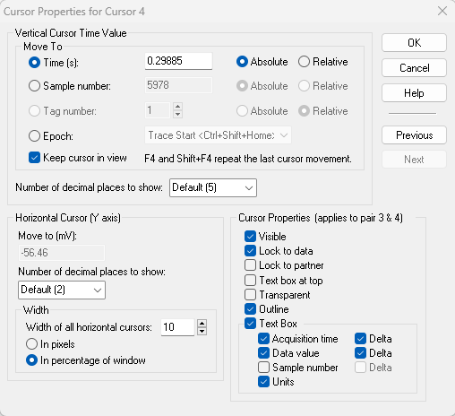
Why were these specific positions chosen?
- Region 1 (cursor 1 and 2) was chosen to be from 0-0.2 seconds because it covers a decently large number of data points before the protocol’s stimulus is applied. This acts as a baseline, or a “0” that we can then compare the injected current sweeps to
- Region 2 (cursor 3 and 4) was chosen because it covers the 2 ms current injection stimulus, without enveloping data points before/after the square wave was at maximum strength.
  - It is ok that the time range in region 2 is actually 1.9 ms, as a slight discrepancy can be explained by the limitations of the 10000 Hz sampling frequency

Trace Analysis Settings:
The signal of interest is the stimulus signal so you can change the trace selection to stimulus to avoid extraneous results cluttering the results tab.
Search Region 1
Verify that the range is between cursors 1 and 2, and the only measurement needed is the mean. This will generate the baseline current of each sweep
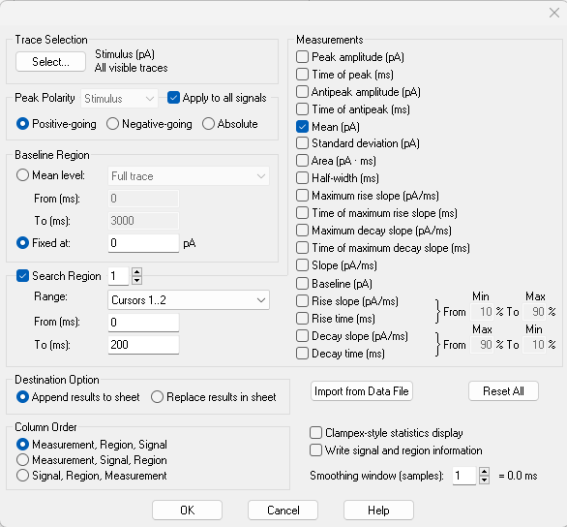
Search Region 2
Verify that the range is between cursors 3 and 4, and the only measurement needed is the mean. This will generate the stimulus current of each sweep
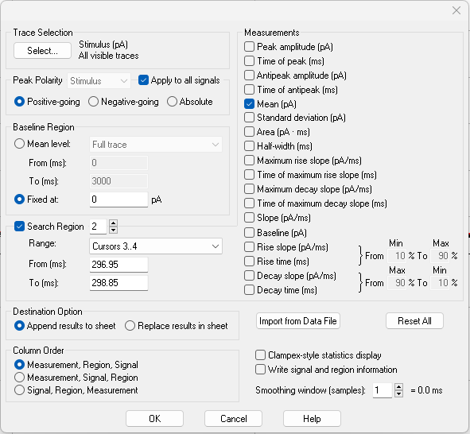
Ensure that no other search regions are active, as that would produce unnecessary columns in the results window
Results Window
These results should be copy and pasted into an excel spreadsheet for further analysis. Below is an example of what the results should look like based on the aforementioned settings.
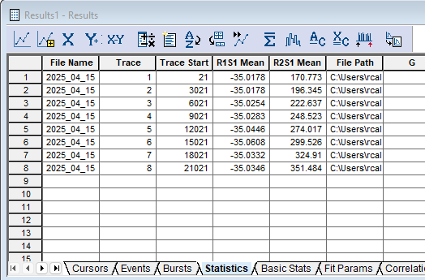
Confirm the sweep with the first Action Potential
To determine which sweep’s values to use for calculating the cell’s current threshold, determine the first sweep in the data set that fires an action potential (the voltage reading is greater than 0 mV). You can scroll through sweeps of interest with the “<” and “>” keys. Make note of the first AP sweep somewhere (the excel file with the clampfit export works well.
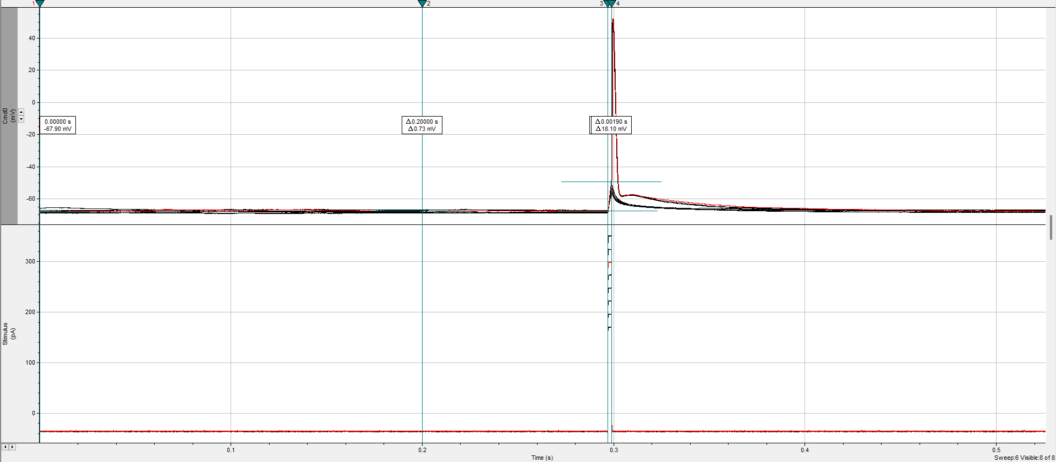
Excel Export Selection
Based on the first AP sweep, select that sweep’s baseline and stimulus values for further calculations
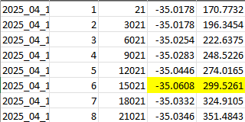
Excel Math
To calculate the current threshold, subtract the baseline value from the stimulus value. In this instance, it was calculated using an excel formula of “=[stimulus cell]-[baseline cell]”
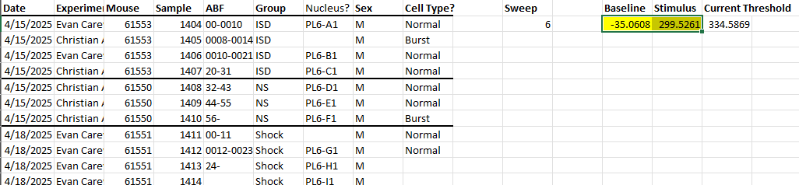
Complete 1 Week of Current Thresholds
Below is an example of a full week of patches with their current thresholds calculated
- The highlighted cells are not indicative of anything; they are simply used to differentiate cells that are next to each other
- The “Spike #” column next to the “Sweep” column isn’t necessary for calculating current threshold. The number of spikes in an action potential at threshold is used to identify burst spiking cells, so it is convenient and efficient to record it while in the abf file to calculate current threshold
- The thick horizontal lines denote each animal, which is also not necessary, but can be helpful for analyzing a large data set.
